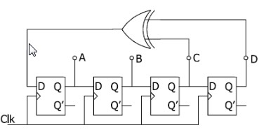

a) Determine the content of register stages after each of the the sub-sequent clock pulses and put results in a table.

| **A** | **B** | **C** | **D** |
| --- | --- | --- | --- |
| 1 | 0 | 0 | 0 |
| 0 | 1 | 0 | 0 |
| 0 | 0 | 1 | 0 |
| 1 | 0 | 0 | 1 |
| 1 | 1 | 0 | 0 |
| 0 | 1 | 1 | 0 |
| 1 | 0 | 1 | 1 |
| 0 | 1 | 0 | 1 |
| 1 | 0 | 1 | 0 |
| 1 | 1 | 0 | 1 |
| 1 | 1 | 1 | 0 |
| 1 | 1 | 1 | 1 |
| 0 | 1 | 1 | 1 |
| 0 | 0 | 1 | 1 |
| 0 | 0 | 0 | 1 |
| 1 | 0 | 0 | 0 |

b) What happens if all stages are initial zero.

* Nothing